Self-Intersecting Curves

Definition
# Source: AI Source: Provided by: [Data Path: Persons Table -> ID Column: 1, Name_En Column: Motasem Essam] -> From: [ChatGPT] on [7/25/2026]
A self-intersecting curve is a curve that crosses or meets itself at one or more points other than its immediate neighboring points.
In other words, while tracing the curve, the path returns to a point that it has already passed through.
$$\boxed{\text{Self-Intersecting Curve}=\text{Curve that Crosses or Meets Itself}}$$
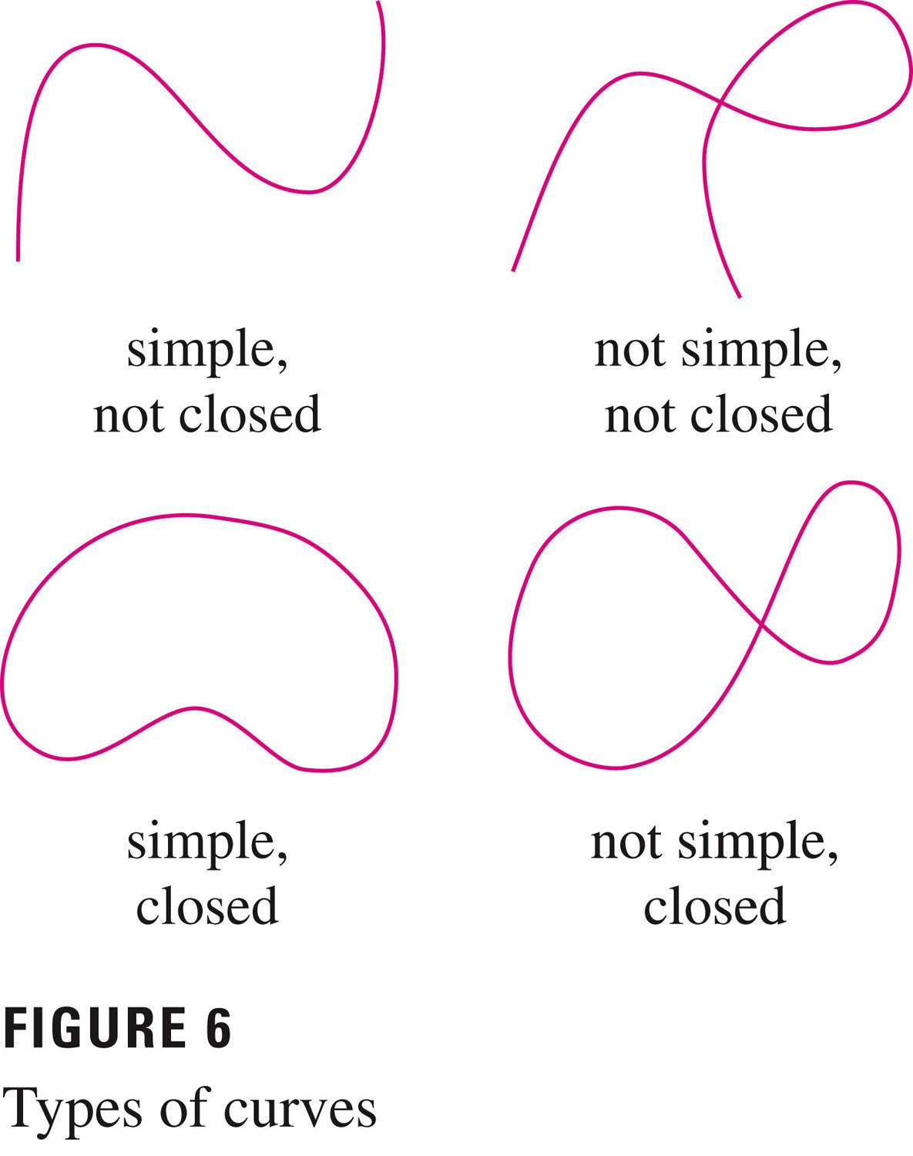
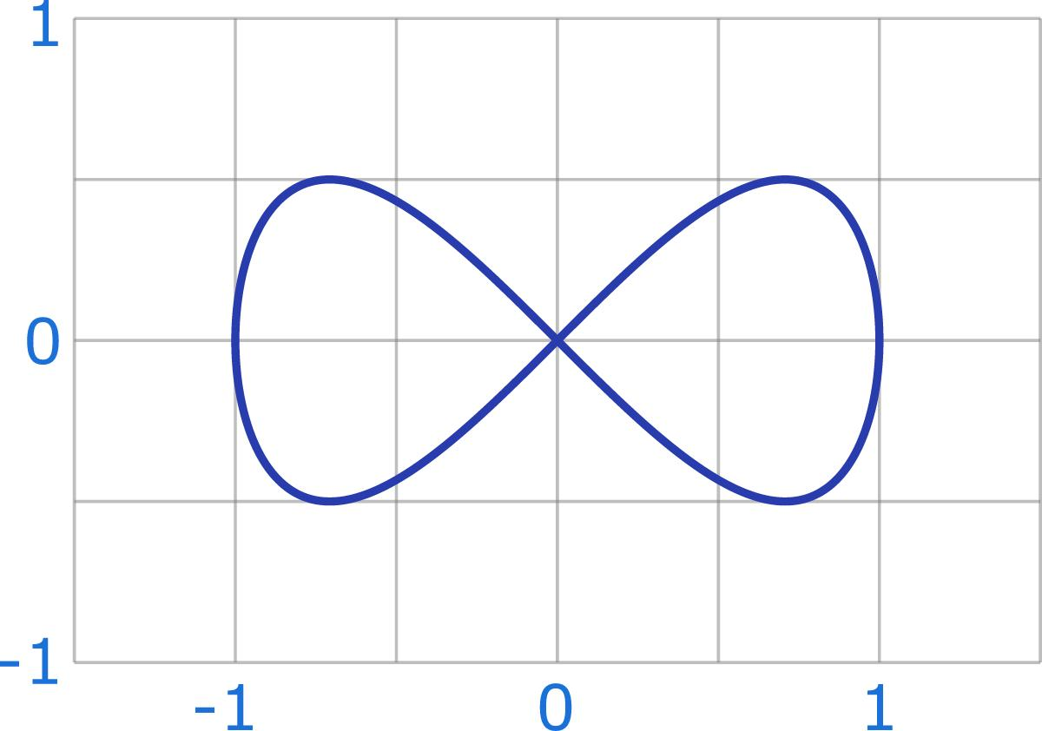
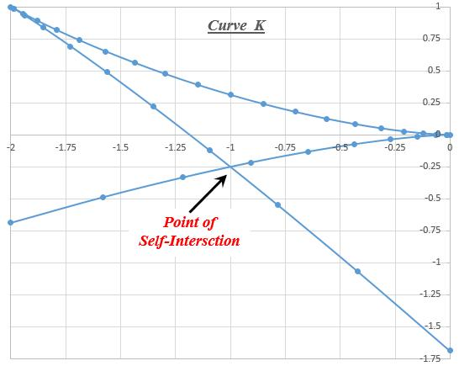
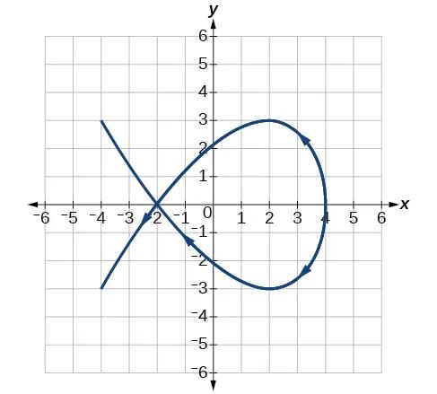
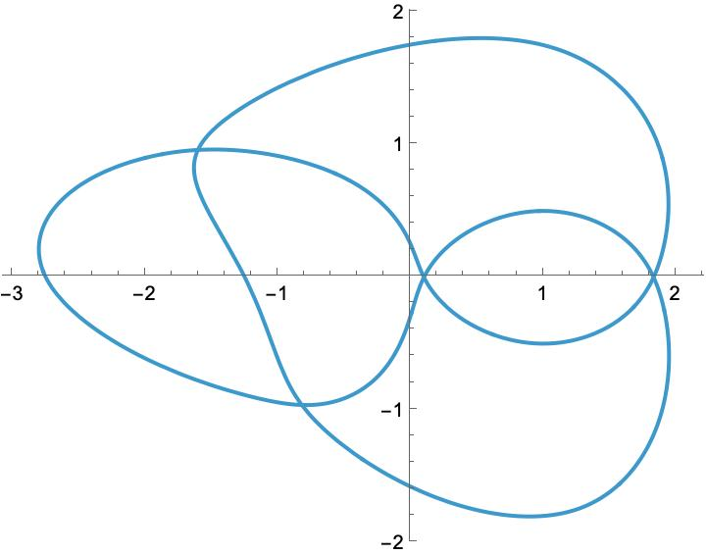

Types of Self-Intersecting Curves

1. Self-Intersecting Open Curves
# Source: AI Source: Provided by: [Data Path: Persons Table -> ID Column: 1, Name_En Column: Motasem Essam] -> From: [ChatGPT] on [7/25/2026]
A self-intersecting open curve crosses itself but has two distinct endpoints.
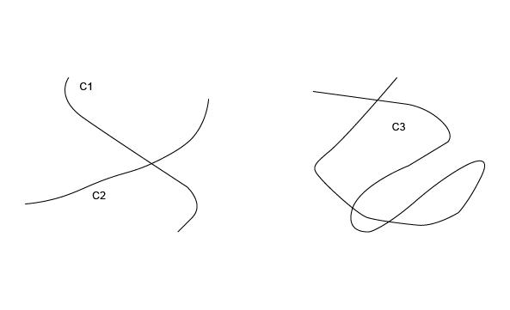
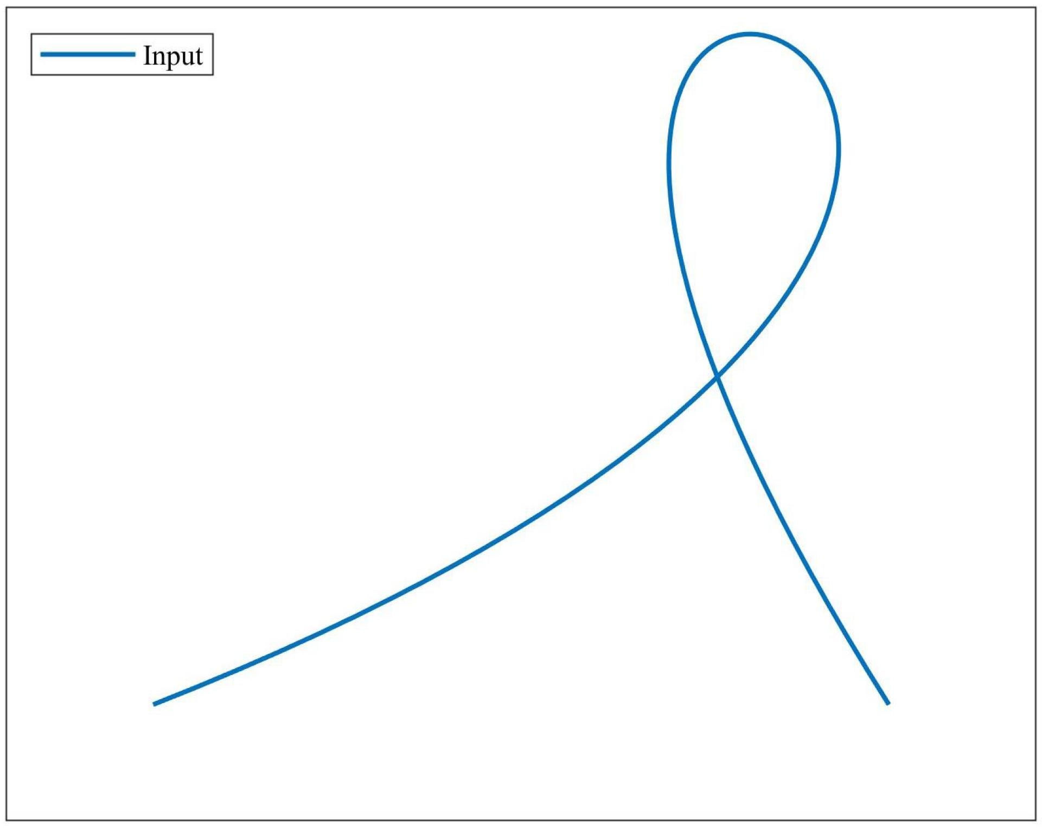
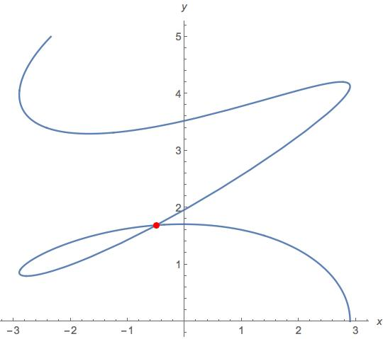
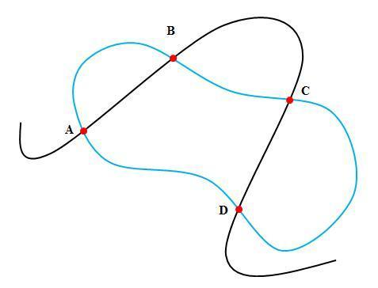
Key Points
- Open.
- Has two distinct endpoints.
- Crosses itself at one or more points.
- Does not form a completely closed boundary.

2. Self-Intersecting Closed Curves
# Source: AI Source: Provided by: [Data Path: Persons Table -> ID Column: 1, Name_En Column: Motasem Essam] -> From: [ChatGPT] on [7/25/2026]
A self-intersecting closed curve returns to its starting point and also crosses itself elsewhere.
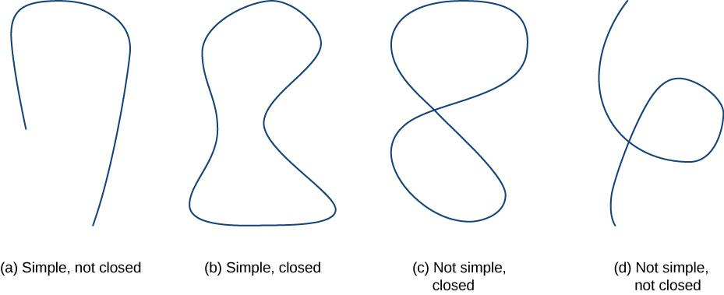
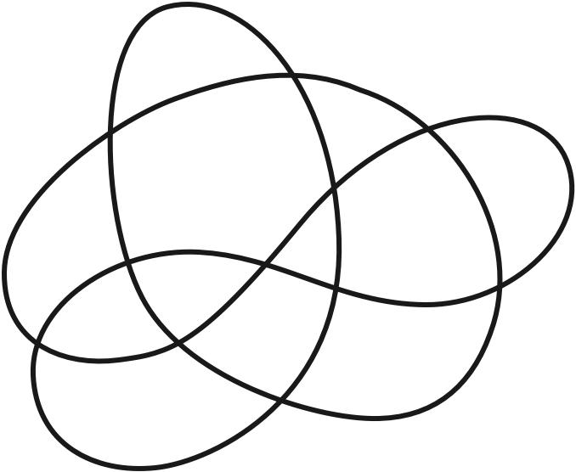
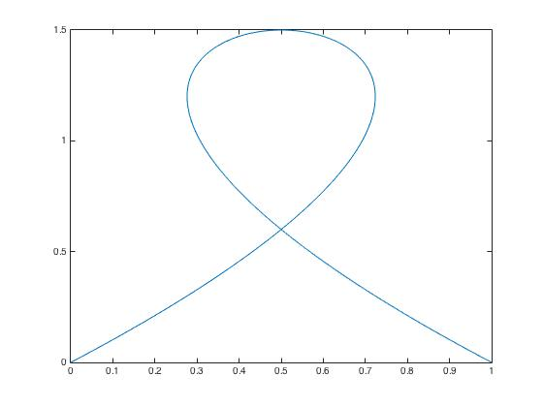
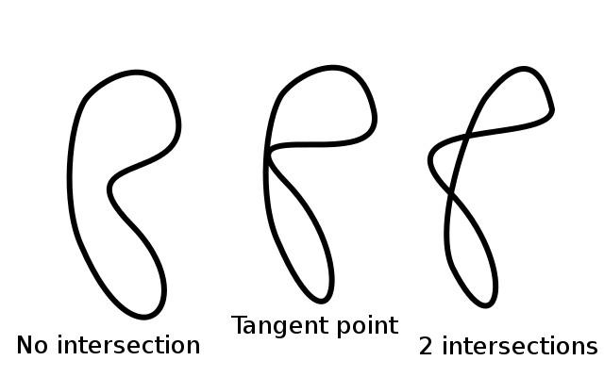
Key Points
- Closed.
- Has no endpoints.
- Starting point equals ending point.
- Contains one or more additional self-intersection points.

3. Figure-Eight Curves
# Source: AI Source: Provided by: [Data Path: Persons Table -> ID Column: 1, Name_En Column: Motasem Essam] -> From: [ChatGPT] on [7/25/2026]
A figure-eight curve consists of two loops that meet or cross at a common central point.
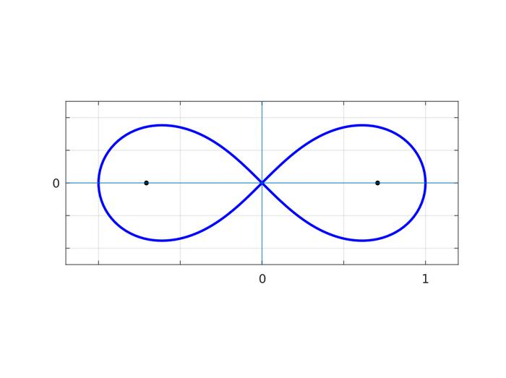
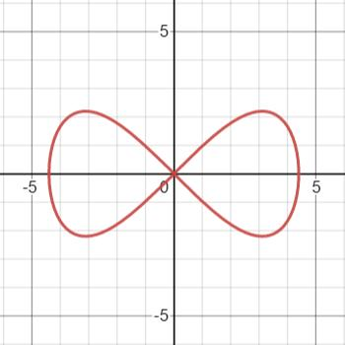
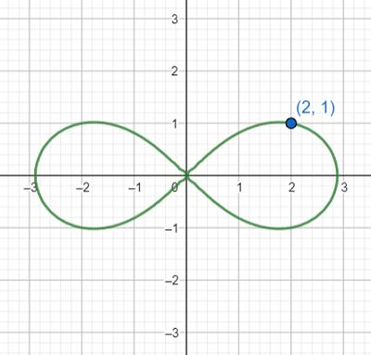
A figure-eight is one of the clearest examples of a self-intersecting curve.

4. Multiple-Loop Self-Intersecting Curves
# Source: AI Source: Provided by: [Data Path: Persons Table -> ID Column: 1, Name_En Column: Motasem Essam] -> From: [ChatGPT] on [7/25/2026]
These curves contain several loops connected through one or more intersection points.
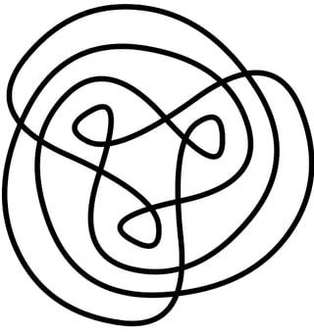
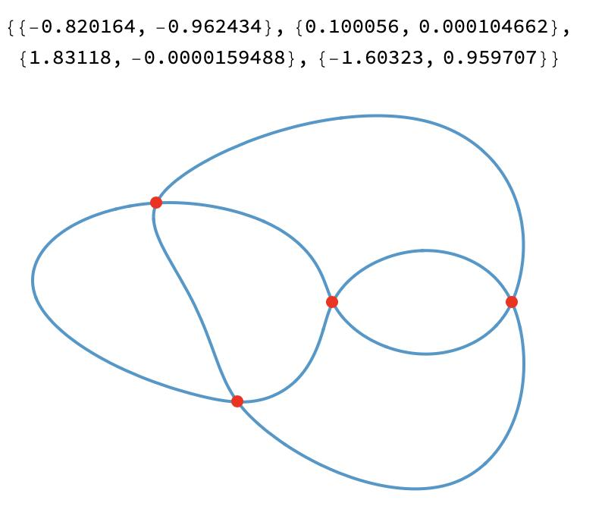
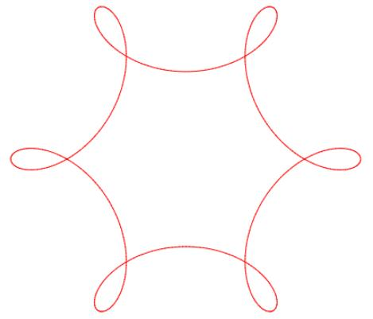

5. Wavy Self-Intersecting Curves
# Source: AI Source: Provided by: [Data Path: Persons Table -> ID Column: 1, Name_En Column: Motasem Essam] -> From: [ChatGPT] on [7/25/2026]
A wavy self-intersecting curve contains waves that become large enough or are arranged so that the curve crosses itself.
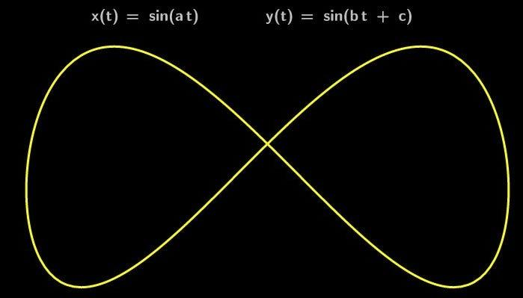

6. Spiral Self-Intersecting Curves
# Source: AI Source: Provided by: [Data Path: Persons Table -> ID Column: 1, Name_En Column: Motasem Essam] -> From: [ChatGPT] on [7/25/2026]
A spiral self-intersecting curve winds around while its path crosses an earlier part of itself.
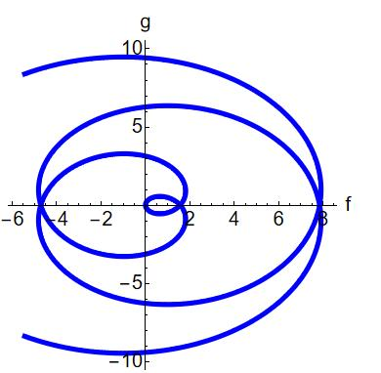
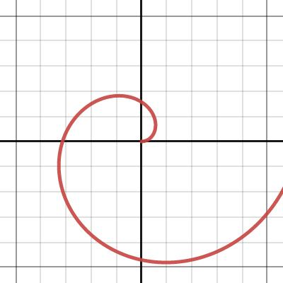
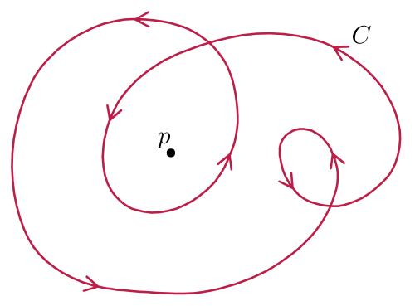

7. Organic Self-Intersecting Curves
# Source: AI Source: Provided by: [Data Path: Persons Table -> ID Column: 1, Name_En Column: Motasem Essam] -> From: [ChatGPT] on [7/25/2026]
An organic self-intersecting curve has an irregular, natural-looking appearance while crossing itself.
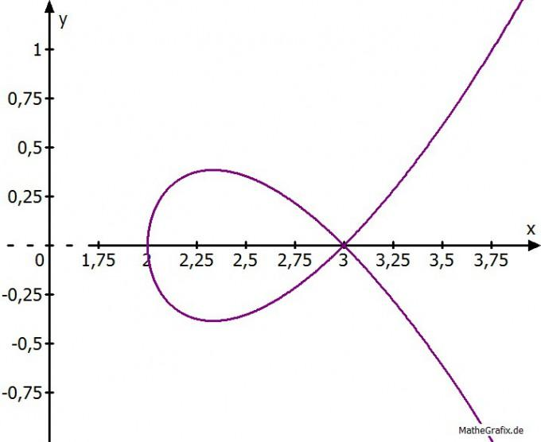

8. Freeform Self-Intersecting Curves
# Source: AI Source: Provided by: [Data Path: Persons Table -> ID Column: 1, Name_En Column: Motasem Essam] -> From: [ChatGPT] on [7/25/2026]
A freeform self-intersecting curve is freely designed and contains one or more self-crossings.
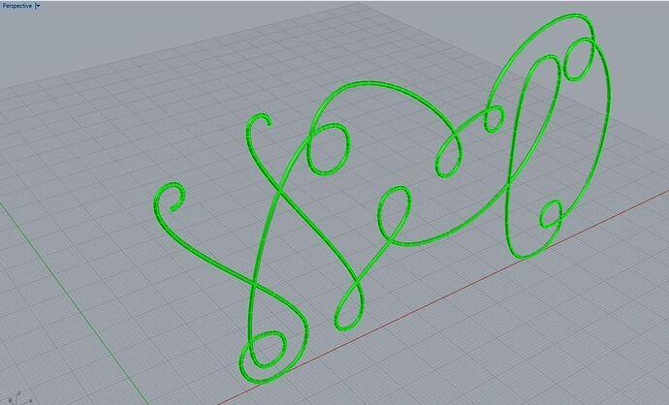
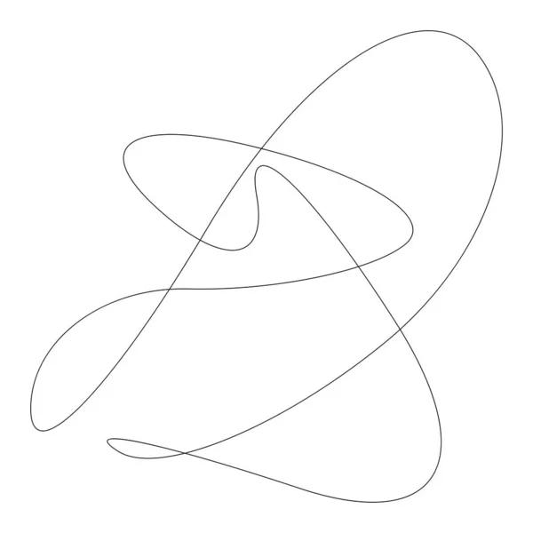
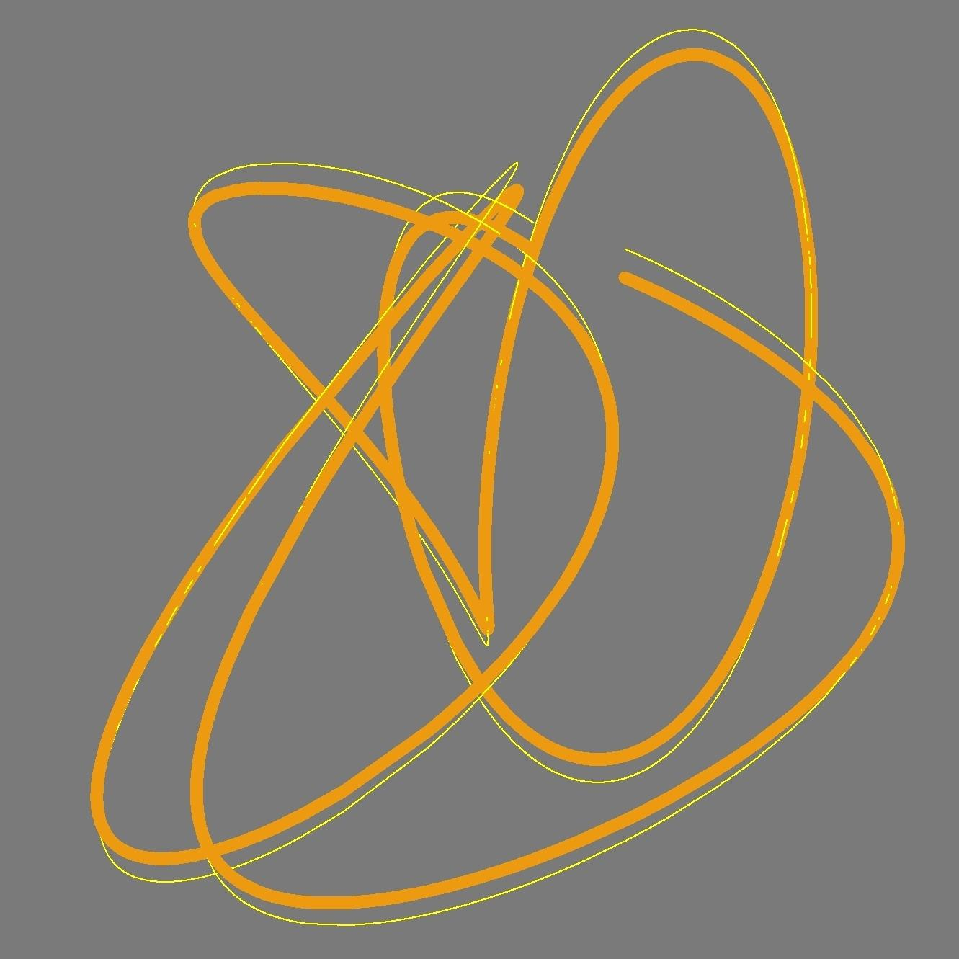

9. Symmetric Self-Intersecting Curves
# Source: AI Source: Provided by: [Data Path: Persons Table -> ID Column: 1, Name_En Column: Motasem Essam] -> From: [ChatGPT] on [7/25/2026]
A symmetric self-intersecting curve has self-intersections while maintaining a recognizable symmetry.
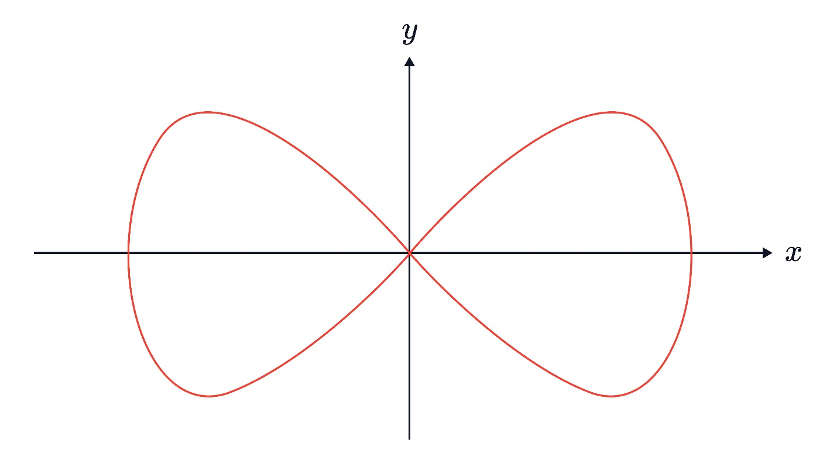
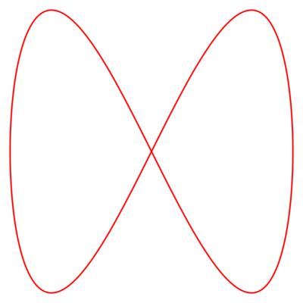
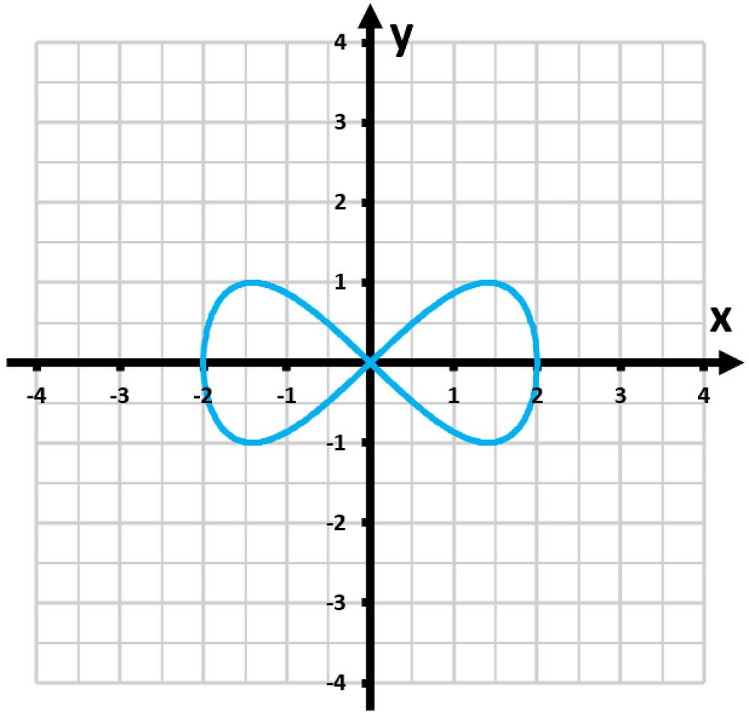

10. Asymmetric Self-Intersecting Curves
# Source: AI Source: Provided by: [Data Path: Persons Table -> ID Column: 1, Name_En Column: Motasem Essam] -> From: [ChatGPT] on [7/25/2026]
An asymmetric self-intersecting curve crosses itself but has no recognizable regular symmetry.
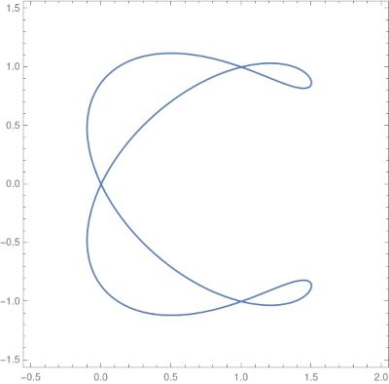
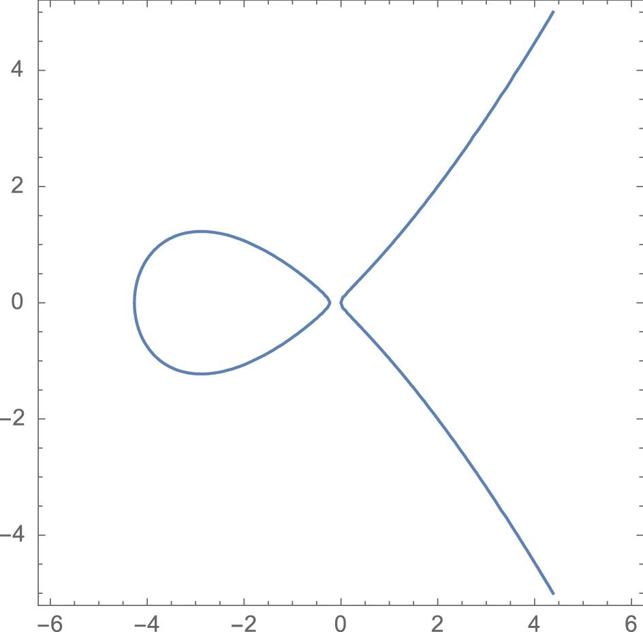

11. Tangential Self-Intersecting Curves
# Source: AI Source: Provided by: [Data Path: Persons Table -> ID Column: 1, Name_En Column: Motasem Essam] -> From: [ChatGPT] on [7/25/2026]
A tangential self-intersecting curve meets itself with the same tangent direction at an intersection point rather than crossing through it sharply.
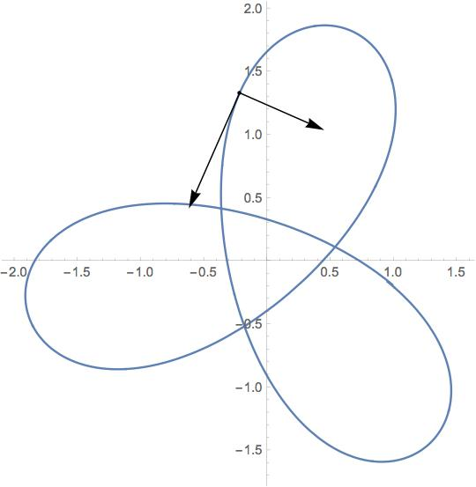
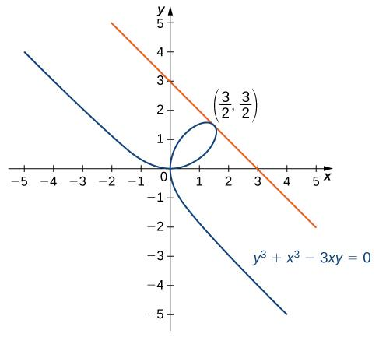
This is different from an ordinary transverse crossing.

12. Multiple-Self-Intersection Curves
# Source: AI Source: Provided by: [Data Path: Persons Table -> ID Column: 1, Name_En Column: Motasem Essam] -> From: [ChatGPT] on [7/25/2026]
A multiple-self-intersection curve contains several distinct points where the curve intersects itself.
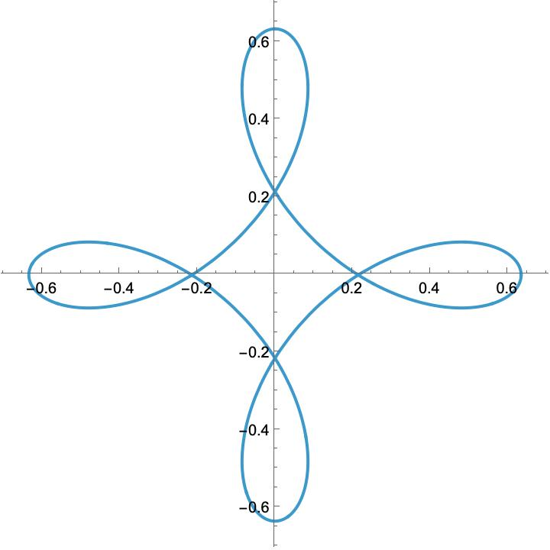

Simple Curves vs. Self-Intersecting Curves
# Source: AI Source: Provided by: [Data Path: Persons Table -> ID Column: 1, Name_En Column: Motasem Essam] -> From: [ChatGPT] on [7/25/2026]
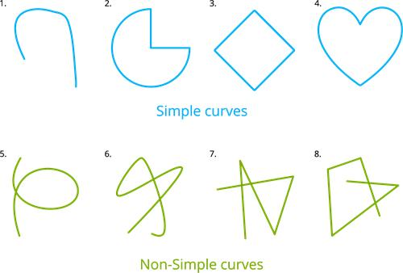
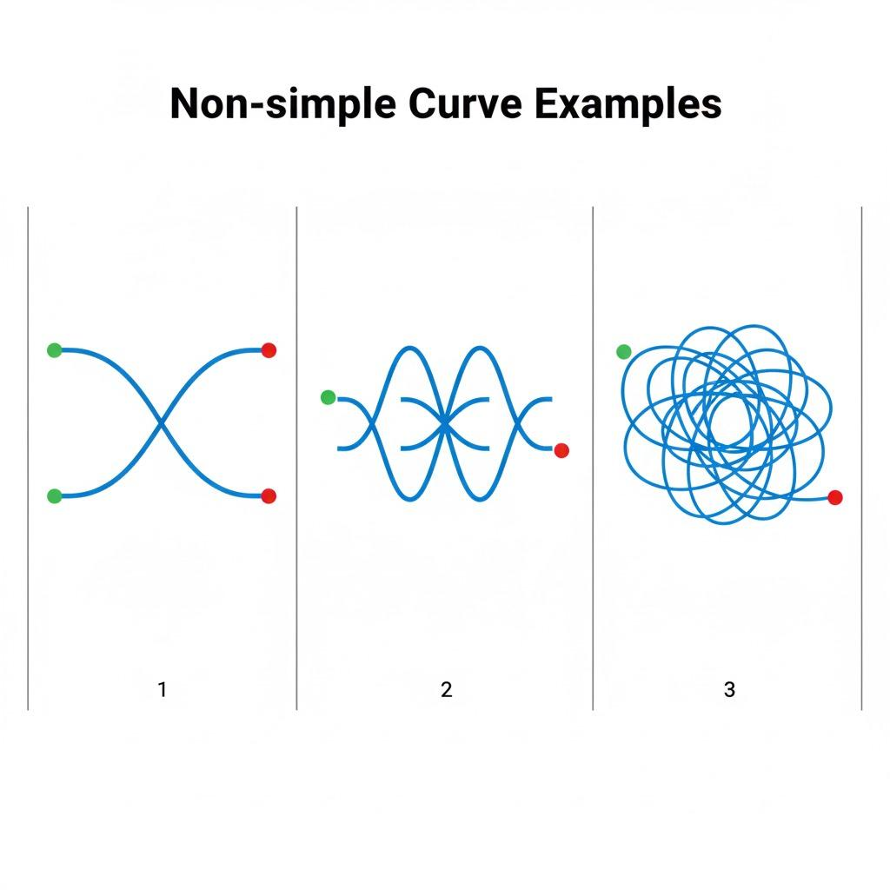
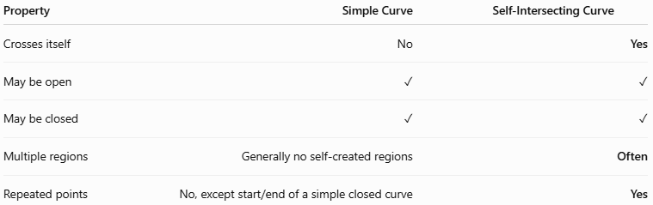
Property | Simple Curve | Self-Intersecting Curve
Crosses itself | No | Yes
May be open | ✓ | ✓
May be closed | ✓ | ✓
Multiple regions | Generally no self-created regions | Often
Repeated points | No, except start/end of a simple closed curve | Yes
Main distinction
$$\boxed{\text{Simple Curve}=\text{No Self-Intersection}} \\ \boxed{\text{Self-Intersecting Curve}=\text{One or More Self-Intersections}}$$

Key Points
# Source: AI Source: Provided by: [Data Path: Persons Table -> ID Column: 1, Name_En Column: Motasem Essam] -> From: [ChatGPT] on [7/25/2026]
A Self-Intersecting Curve:
$$\boxed{\text{Self-Intersecting Curve}=\text{Curved Path}+\text{Repeated/Intersecting Point(s)}}$$
It:
- Crosses or meets itself.
- Can be open or closed.
- Can contain one or many loops.
- Can have one or many self-intersection points.
- Can be symmetric or asymmetric.
- Can be wavy, spiral-like, organic, or freeform.
- May create multiple enclosed regions when closed.

Conclusion
# Source: AI Source: Provided by: [Data Path: Persons Table -> ID Column: 1, Name_En Column: Motasem Essam] -> From: [ChatGPT] on [7/25/2026]
Self-Intersecting Curves are curves whose paths cross or meet themselves at one or more points. They can take many forms, from simple figure-eight curves to highly complex curves with multiple loops and intersections.
The defining property is:
$$\boxed{\text{Self-Intersection}=\text{The Curve Meets Its Own Earlier Path}}$$
Therefore, unlike a simple curve, a self-intersecting curve may pass through the same point more than once, creating loops or multiple regions in the case of closed curves.

